**Antimetabolite drugs**

Purine and pyrimidine antagonists are required activation by phosphorelated inside the body into nucleotide form in order to be cytotoxic.

3- Folic Acid antagonists (Antifolates):

Folic acid and the structures of the major antifolate anticancer drugs are shown of the following: Methotrexate, Pemetrexed, Nolatrexed and Raltitrexed.  
- Antifolate cpds has been proven in treatment of varity of hematological and nonhematological malignancies.

Methotrexate is the classic antimetabolite of folic acid structurally derived by N-methylation of para-aminobenzoic acid residue(PABA) and replacement of a pteridine hydroxyl by the bioisosteric amino group.

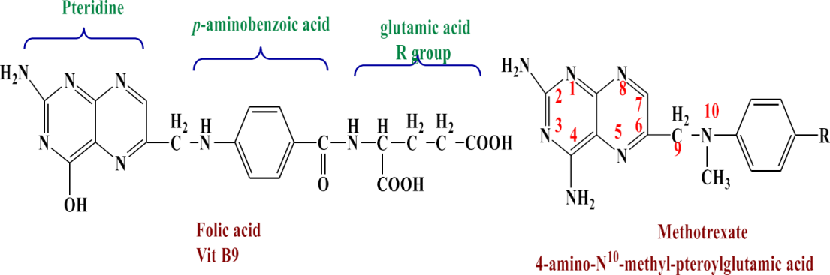

The conversion of –OH to -NH2  increases the basicity of N-3 and yields greater enzyme affinity. This drug competitively inhibits the binding of the substrate folic acid to the enzyme DHFR, resulting in the reductions in the synthesis of nucleic acid bases, perhaps most importantly, the conversion of uridylate to thymidylate as catalyzed by thymidylate synthetase. In addition, purine synthesis is inhibited because the N-10-Formyl tetrahydrofolic acid is a formyl donor involved in purine synthesis.

Mechanism of action of folic acid antagonist  
 folic acid antagonist  
 ↓  
 limiting thymidylate synthesis  
 ↓  
 prevent DNA synthesis  
 ↓  
 kill cells  
This effect has been termed thymineless death.

Methotrexate inhibits DHFR enzyme, therefore, it inhibits the synthesis of DNA, RNA & Proteins.

DHFR catalyses the conversion of FH2 to the active FH4 which is needed for the de novo synthesis of deoxynucleoside thymidine phosphate DTMP(required for DNA synthesis).



**Methotrexate**



-High dose from Methotrexate (MTX) therapy, is associated with sever nephrotoxicity. So, do not administer high dose to patients with abnormal renal function.

Interaction between MTX & 5-FU :   
MTX preceding 5-FU; Synergistic cytotoxicity.

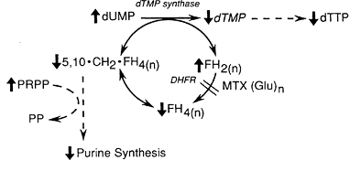

2-**Pemetrexed**\* Its potents Thymidylate Synthase inhibitor (TS-I ), is logical target for pemetrexed.  
* Pemetrexed is transported into cells via the reduced-folate carrier (RFC) and possibly by a unique transporter identified in mesothelioma cell lines.  
- It metabolized to polyglutamated forms, which are potent inhibitors of thymidilate synthase (TS) enzyme.

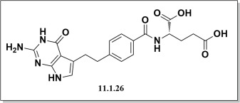

**3- Nolatrexed**  
- It is Non-classic-Inhibitor of TS, specifically designed to avoid potential resistance mechanisms that can limit the activity of classic antifolate antimetabolites.   
* It is lipophilic drug characterized as non-glutamate containing

Molecule that does not require facilitated transport for uptake and does not undergo, nor require, intracellular polyglutamylation for activity.

**4- Raltitrexed**\* It is H2O soluble thymidilate synthetase (TS) inhibitor, that appears to have an acceptable toxicity profile  
* it is antitumor activity in colorectal, breast, pancreatic and avarity of other solid cancers.  
* it a 2nd generation agent designed to overcome the major toxicity associated with its predecessor .

